FUNCTION 1 (isWordGuessed)

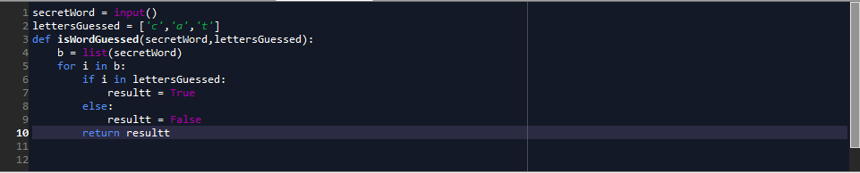

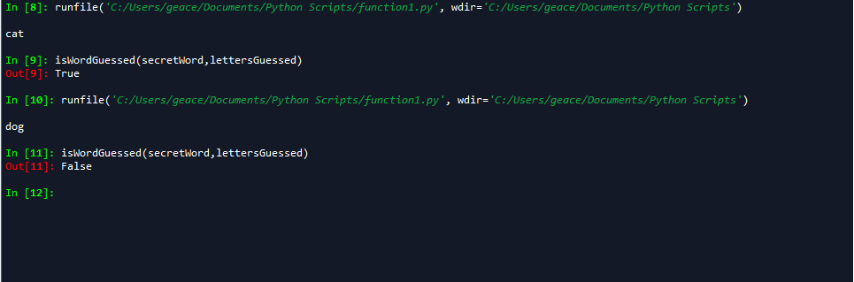

FUNCTION 2 (getGuessedWord)

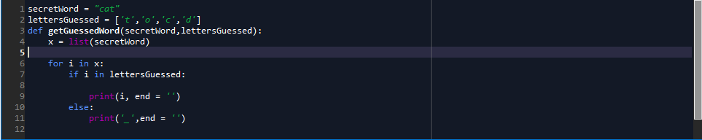

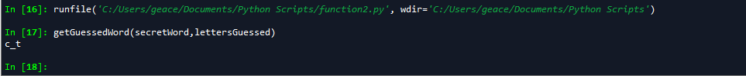

FUNCTION 3(getAvailableLetters)

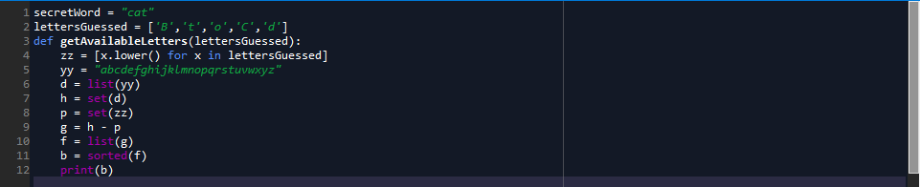

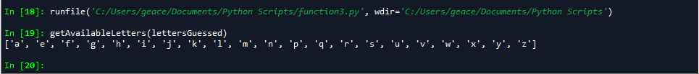

HANGAROO FUNCTION

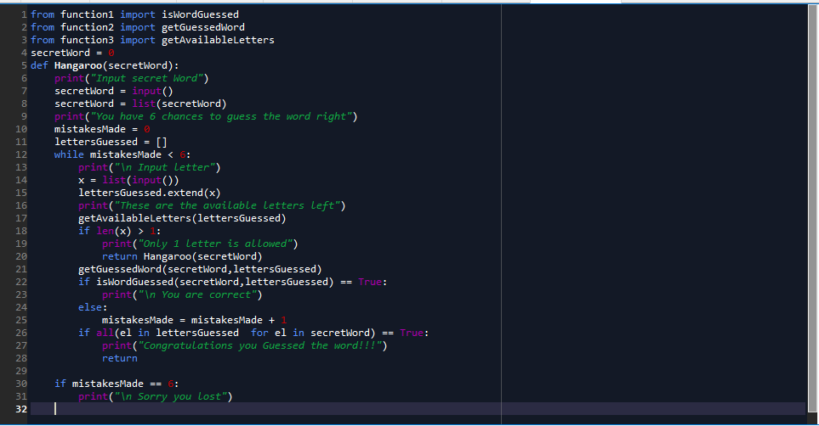

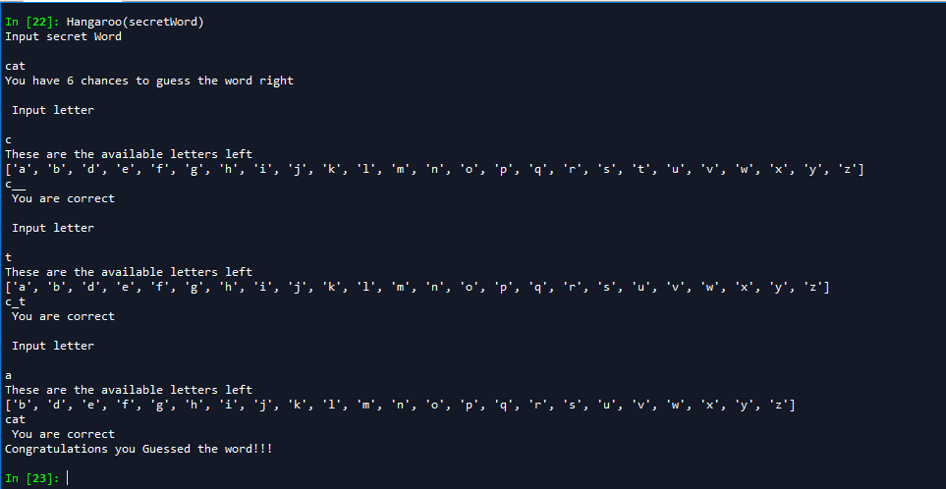

Scenario 1 guessing the letter wrong 6th consecutive times

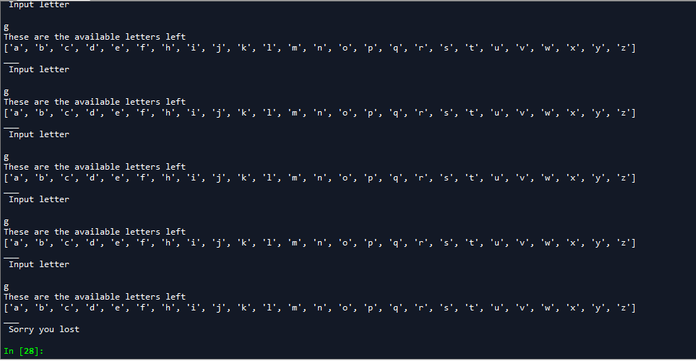

Scenario 2 if user input 2 letters

